Submission of documents via My Mailbox service

From April 2021, Medical Institutions may submit a scanned copy of the Letter of Undertaking (LUT) and MBE01 Forms to CPF Board according to their business entity via CPF Board’s My Mailbox service by logging in with the clinic’s SingPass / CorpPass.
You may assess our website page for business partners at https://www.cpf.gov.sg/members/bptopics.
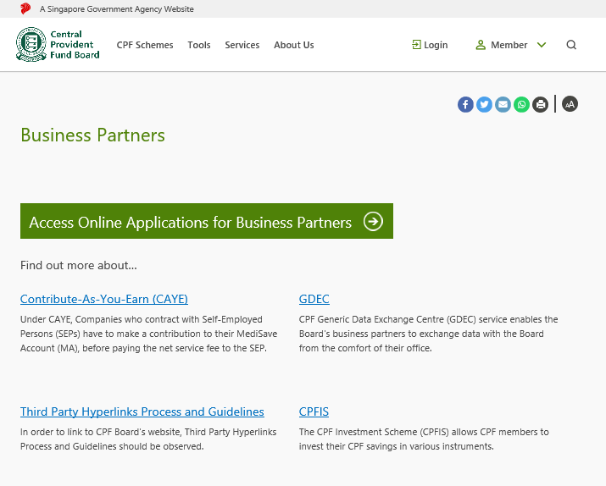

Upon clicking the link “Access Online Application for Business Partners” as shown above, you will be redirected to the SingPass / CorpPass login page. Please login with your SingPass / CorpPass details and you will be able to assess CPF Board’s Business Partners Online Services.

Submission of documents via My Mailbox service (cont’)

After you have login to the website successfully, you will be able to assess the webpage below, Click on “My Mailbox” as shown via the blue arrow below and you will be able to see the “New Enquiry” button. Click on the “New Enquiry” button as shown below.
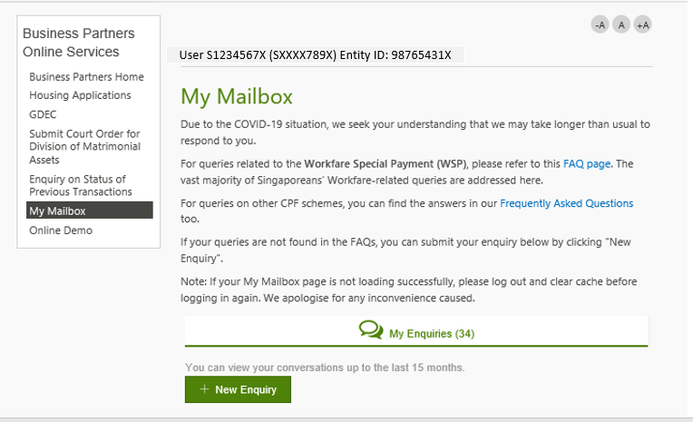

After clicking the “New Enquiry” button, the following screen will appear:
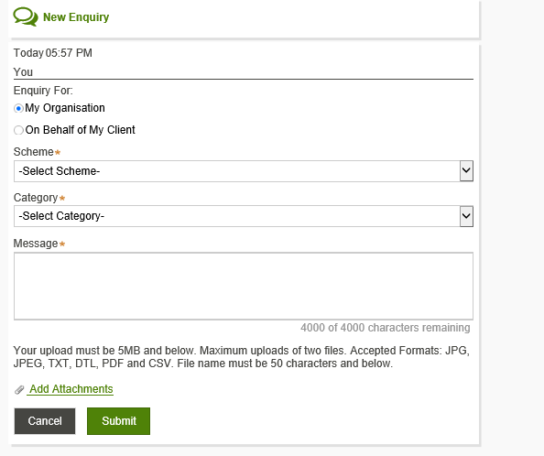

Submission of documents via My Mailbox service (cont’)

- Submission of documents for the organisation
- Under “Enquiry For”, select “My Organisation” and under ”Scheme”, select “MediSave / MediShield Life” as shown:
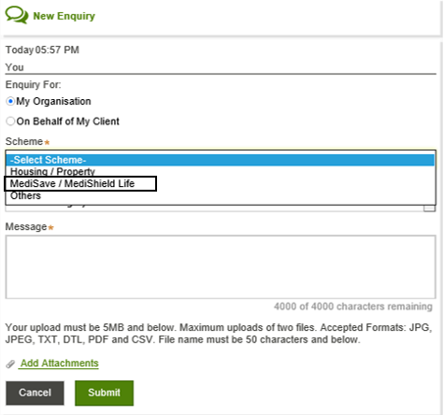

Submission of documents via My Mailbox service (cont’)

- Under “Category”, select “Accreditation” as shown:

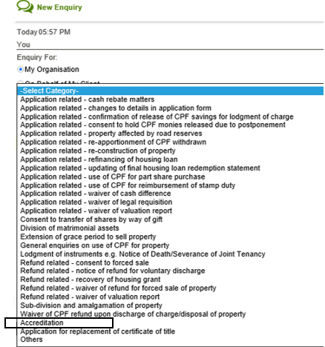

Submission of documents via My Mailbox service (cont’)

- Under “Message”, please include the subject “Application for MBE”, business owner’s name and clinic(s)’ name(s) as shown:

Application for MBE
ABC Clinic Pte Ltd
ABC Clinic

Submission of documents via My Mailbox service (cont’)

- Upload the required documents by clicking on the “Add Attachments” button as shown:

- Lastly, click on the “Submit” button above and the document submission process is completed.

CPF Board Contact Details on MBE Application matters.

Contact Details
Telephone | 6202 4140
Email Address | medclm@cpf.gov.sg

